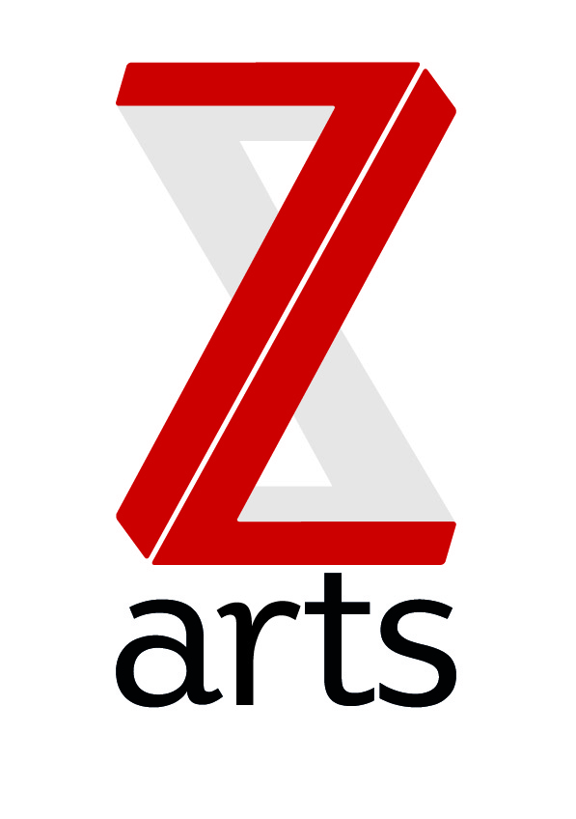
Theatre Bar Price List

Budvar Bottles £3.00
Red Stripe £3.00
Erdinger Bottles £3.50
Guinness £3.50
Flavoured Cider £3.80
Magners £4.00
Fruit Beers £3.50
Bottled Ale £3.50
Boddies! £3.00

All Spirits £3.00
With mixer £3.50
Double with mixer £5.00

Fruit Juice half pint £1.00
Mineral Water £1.50
Cans of Pop £1.00
Ginger Beer £1.75

Glass any wine £2.50 (125ml)
Bottle any wine £10.00

Hot Drinks available in the Café Bar
Tea £1.50 Coffee £1.80 Hot Choc 2.00
Snacks various prices-see server for details

Hungry?...

Not had time for breakfast?....
- Mini cereal box, piece of toast and any tea £2.50
- Scrambled Eggs on Toast £2.50
- Baked beans on toast £2.50
- (try ‘em spicy or cheesy!)
- Toasted teacakes or Crumpets with a shot of honey or a pot of jam £1.50

Light lunch menu
- Freshly prepared sandwiches (see board for selection)
- Served with mixed dressed salad £3.50
- Soup of the day £2.50
- Soup with any sandwich £4.50
- Tomato and red onion salad (v) £2.50
- Moroccan style salad (v)£3.00

Toasted delights!
- Fish finger or veggie finger butties! £1.00 kids size or £2.00
- Toasted sandwiches £2.00
- Choose from ham and cheese, 2 cheese and tomato, tuna melt, hummus and pepper

Easy evening eats…
- Cheese, bread and meat deli platter with spicy olives £6.50
- Cheeky prawn cocktail 80’s style £4.50
- Toasted pitta served with hummus and olives (v)£3.25
- get a bottle of wine with any of the above for just £8.50

Tenants, call the café on 226 with your food order, we’ll ring you back when its ready!

